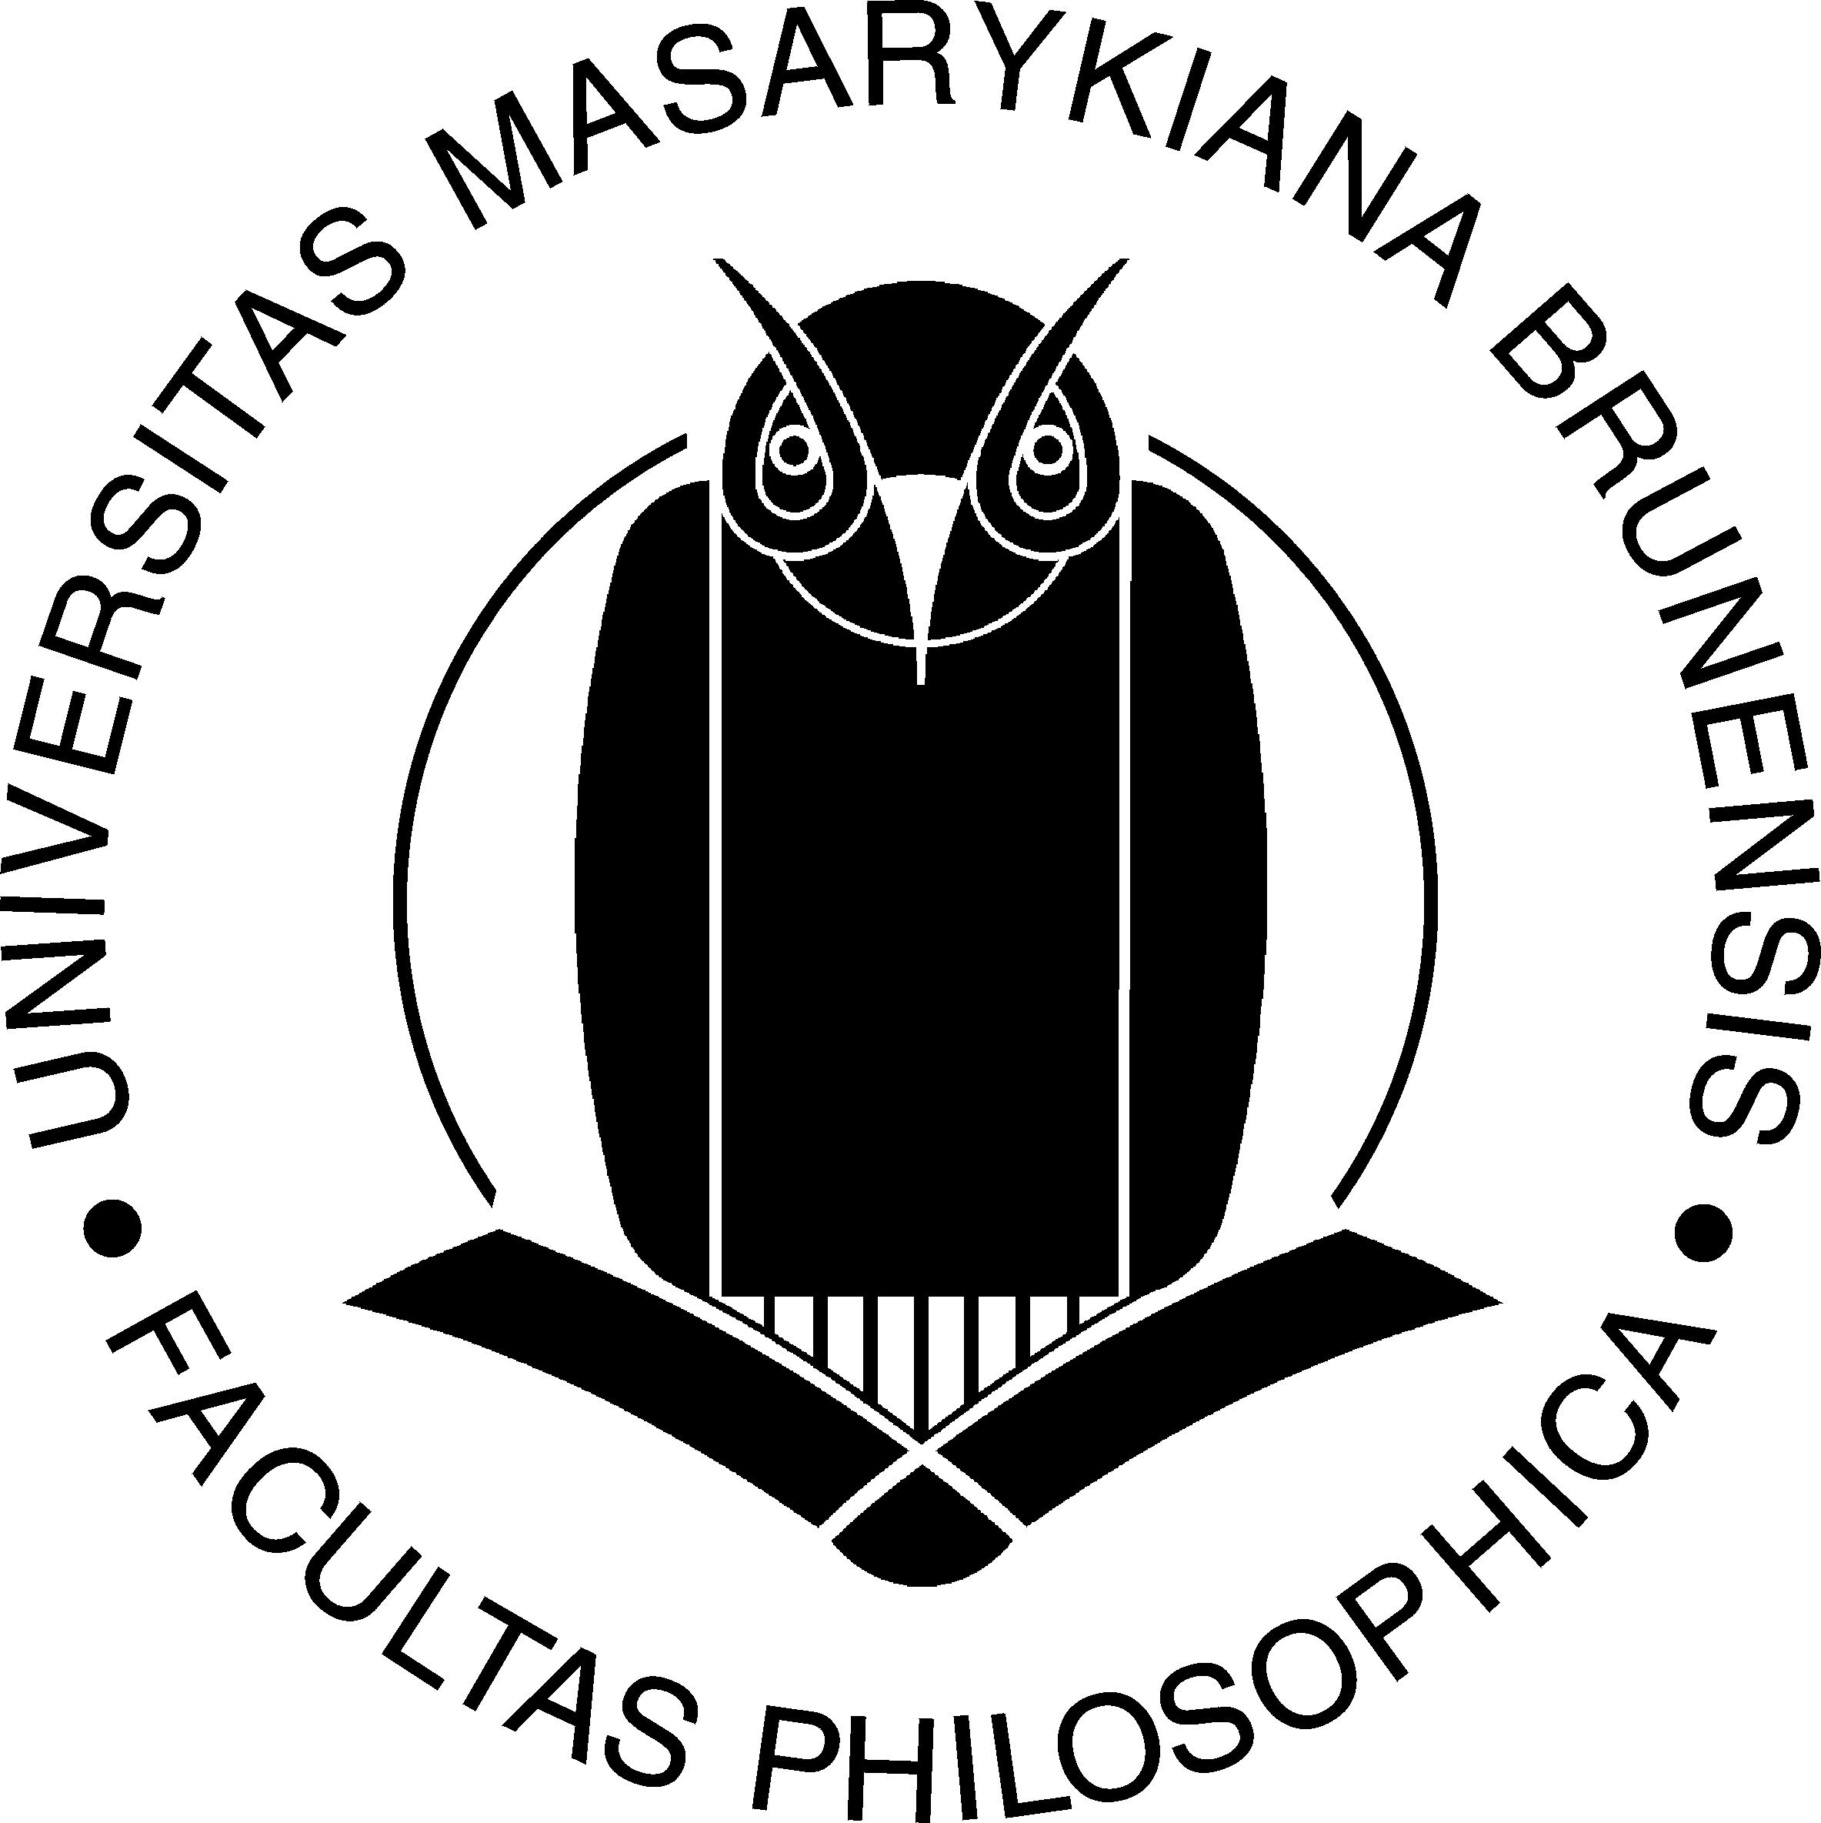
Second Call for Papers
The Eighth Brno Conference of
English, American and Canadian Studies
The Department of English and American Studies at the Faculty of Arts of Masaryk University in Brno is pleased to once again host this international conference from February 2 to 4, 2005.
Proposals for papers from university-based scholars in the subfields of linguistics, literature, cultural studies, translation and language teaching methodology are welcomed. Due to the number of papers, presentations are limited to twenty minutes. The deadline for submitting your 100-word proposals is:
December 15, 2004
The conference fee is 1,500 Kč (including VAT/DPH) for participants from the Czech Republic and Slovakia.
The fee for Post-graduate students is 750 Kč
For participants from other countries, the fee is €75.
The conference fee includes:
– Conference and informational materials
– Full Board
– Formal reception on opening night
– Coffee breaks
– The conference proceedings
(participants may choose not to receive the proceedings; their fees will be reduced to 1,250 Kč or 500 Kč for PGS)
Accommodations for conference participants have been reserved at Masaryk University’s Hotel Garni and the cost will be covered by the host department.
Conference registration is available online by visiting:
http://www.phil.muni.cz/angl/conference/confer.htm
If you are interested in displaying books, journals, posters or other materials, please contact the organizers.
The Department of English and American Studies is also pleased to host the General Assembly of the ČAA/ESSE following the close of the conference on February 4, 2005 at 1 p.m. Conference participants and all other interested parties are welcome to attend this meeting.
Additional information is available at our website, via email at drabek@phil.muni.cz, kolinska@phil.muni.cz or by calling +420/549496660

